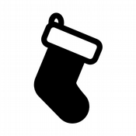Shop Local at Lake Limerick Pro-Shop & Café
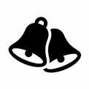12 Days of Christmas Specials 2020

Begins Sunday, December 13, to Thursday, December 24, 2020

- December 13: Punch Card Special: For each Punch Card sold, get 2 free sleeves of Srixon balls, and 15% Off one breakfast or lunch item.
- December 14: Free 2021 Lake Limerick Calendar: Spend $50 in Pro Shop Merchandise and receive a free 2021 Calendar.
- December 15: 25% Off Re-Grips (max. 2 Clubs).
- December 16: Free round of golf with each paid cart rental.
- December 17: 35% Off all Golf Accessories.
- December 18: Two for One Golf, 9 or 18 Holes. Tee Time after 12PM.
- December 19: $5.00 + tax, Hot Dog Special & a Non-Premium Drink.
- December 20: 20% Off all Headwear, and 20% Off your Lunch ticket for 4, (alcohol excluded).
- December 21: 2 for 1 Round of Golf, 9 or 18 Holes, Book your Tee Time today for any day between Dec. 26-31.
- December 22: 50% Off your Cart Rental.
11.December 23: 20% Off Pro-Shop Select Logo Apparel.
12.December 24: 25% Off Select Golf Balls. Great for Stocking Stuffers.

From All of Us, at the Pro-Shop and Café,
Merry Christmas and a Very Happy New Year 2021!
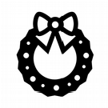Lake Limerick Golf Club & Café

